NORMALIZATION EXERCISE
Joe's Video Store — View 2
Video Information · Individual work
Overview

Scenario
Joe wants you to develop a small database application to help him run his video rental store. Tracking video information is one system requirement.
Your Task
You are to develop a view schema in 3NF for the Video Information view. You will show the schema in ERD notation and document any assumptions you make.
Format: Individual work

The Source Document

Joe's Video Store: Video Information
Video Id: Hor-1 | Title: Carrie
Type Id: 1 | Type Name: Horror Movie
Total no of copies: 5 | No of copies available for rental: 2
Format: VHS | Rental Charge: $3.00
Cost: $9.00 | Rating Code: R
 | Rating Description: Restricted Adult

Copy Number | Available for rental
1 | no
2 | no
3 | Yes
4 | Yes
5 | no

Business Rules
1. Movie Types are: Horror, Comedy, Action, Romance, Science Fiction, ...
2. Formats are: VHS, VCD, DVD.
3. Movie Ratings are: Children, Youth, Adult, Restricted Adult, and X-Rated.
4. Copy Number is unique within Video Id (the first copy of any given video is copy number 1).

Step 0 — Create the Initial Table (0NF)

What to do
1. List all data items from the source document.
2. Identify the primary key (underlined).
3. Identify any repeating groups (place in parentheses).
Attributes to include
Attribute
Video ID
Video Title
Video Type ID
Video Type Name
Number Of Total Copies
Number Of Available Copies
Video Format
Video Rental Charge
Video Cost
Video Rating Code
Video Rating Description
Video Copy Number
Available For Rental YN

Hint: The repeating group is the set of copy attributes that can have multiple values for a single video (a video can have several physical copies).

Write your 0NF table here:
Video(VideoID, Title, TypeID, TypeName, NumberOfCopies, NumberOfAvailableCopies, Format, RentalCharge, Cost, RatingCode, RatingDescription, (CopyNumber, AvailableForRental))

Step 1 — Apply First Normal Form (1NF)

Rules
1. A table must contain only atomic attributes.
2. A table cannot contain any repeating groups.
What to do
1. Remove the repeating group: move Copy Number and Available For Rental to a new table.
2. Copy the primary key (VideoID) into the new table as a foreign key.
Designate a primary key for the new table:
• Can VideoID alone uniquely identify a row in the new table? (No — one video can have many copies)
What combination works? VideoID + CopyNumber
Write your 1NF tables here:
Table 1: Video
VideoID (PK), Title, TypeID, TypeName, NumberOfCopies, NumberOfAvailableCopies, Format, RentalCharge, Cost, RatingCode, RatingDescription

Table 2: VideoCopy
VideoID (FK), CopyNumber, AvailableForRental
Primary key: VideoID + CopyNumber

Step 2 — Apply Second Normal Form (2NF)

Rule
All non-key attributes must fully depend on the entire primary key.
A 2NF violation can only occur in a table with a composite primary key.
• Video table has a single PK (VideoID) → No 2NF violation possible
• VideoCopy table has a composite PK (VideoID + CopyNumber) → must evaluate

What to do
1. Evaluate the non-key attribute in VideoCopy:
Attribute | Depends on VideoID? | Depends on CopyNumber? | Fully Dependent on Entire PK?
AvailableForRental | No | No | Yes

2NF — No Violation. AvailableForRental depends on the whole key (a specific copy of a specific video), so the tables carry forward unchanged.

Write your 2NF tables here:
Table 1: Video
VideoID (PK), Title, TypeID, TypeName, NumberOfCopies, NumberOfAvailableCopies, Format, RentalCharge, Cost, RatingCode, RatingDescription

Table 2: VideoCopy
VideoID (FK), CopyNumber, AvailableForRental

Step 3 — Apply Third Normal Form (3NF)

Rule
A non-key attribute cannot be fully dependent on another non-key attribute.
A table must have two or more non-key attributes for a violation of 3NF to occur.

What to do
1. Evaluate the Video table for transitive dependencies:
Non-Key Attribute | Depends On | Violation?
TypeName | TypeID (non-key) | Yes — transitive dependency
RatingDescription | RatingCode (non-key) | Yes — transitive dependency
Format | a predefined list, like TypeName/RatingDescription — but no ID column exists on the source view | Yes, in principle — needs a technical key (see note)

Note on Format: Since we have a predefined list of Formats (VHS, VCD, DVD, etc.), this attribute is of a similar type as TypeName and RatingDescription. The only difference is that there is no FormatID shown on the source view. A technical key, FormatID, should be added to identify Format — this creates another table in 3NF, even though it was not an explicit attribute on the original screen.

2. Fix the transitive dependencies:
- Remove TypeName from Video; place it in a new table, VideoType. TypeID becomes the primary key of VideoType and remains in Video as a foreign key.
- Remove RatingDescription from Video; place it in a new table, Rating. RatingCode becomes the primary key of Rating and remains in Video as a foreign key.
- Add a technical key, FormatID, and create a new table, Format(FormatID, FormatDescription). Replace the Format description in Video with FormatID as a foreign key.

Write your 3NF tables here:
Table 1: Video
VideoID (PK), Title, TypeID (FK), NumberOfCopies, NumberOfAvailableCopies, FormatID (FK), RentalCharge, Cost, RatingCode (FK)

Table 2: VideoType
TypeID (PK), TypeName

Table 3: Rating
RatingCode (PK), RatingDescription

Table 4: Format
FormatID (PK), FormatDescription
Technical key — added because the source view shows Format as a description only, with no ID.

Table 5: VideoCopy
VideoID (FK), CopyNumber, AvailableForRental

Step 4 — Draw the ERD

What to do
1. Draw each table as a box.
2. List attributes inside each box.
3. Underline the primary key.
4. Mark foreign keys with (FK).
5. Draw relationship lines between tables.
6. Add cardinality symbols (1, M).
ERD Layout
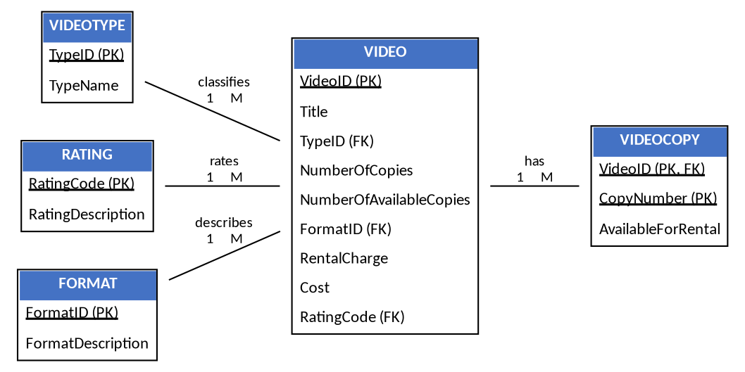

Relationships
Entity A | Relationship | Entity B | Type
VideoType | classifies | Video | 1:M
Rating | rates | Video | 1:M
Format | describes | Video | 1:M
Video | has | VideoCopy | 1:M

Assumptions to Document

Write down any assumptions you made during the normalization process.
Examples
1. A technical key, FormatID, was added because the source view lists Format as a description only, even though it behaves like a predefined list (similar to Video Type and Rating).
2. Video Copy Number is unique only within a Video ID, not globally, so the primary key of VideoCopy is VideoID + CopyNumber.
3. NumberOfTotalCopies and NumberOfAvailableCopies are attributes of the video as a whole and are kept in the Video table rather than derived by counting VideoCopy rows.
4. Each Video Type, Rating, and Format comes from a fixed, predefined list of values.
Write your assumptions here:

Submission Requirements

Create
1. Your 0NF table (initial table)
2. Your 1NF tables
3. Your 2NF tables
4. Your 3NF tables
5. Your ERD (hand-drawn or digital)
6. Your documented assumptions
Format
- Handwritten or typed
- Clear labels for PK, FK, and composite keys
- Underline primary keys
- Use parentheses for repeating groups in 0NF

Hints and Tips

Tip | Explanation
Start with 0NF | List everything first. Don't try to organize until you see all the data.
Underline the PK | In 0NF, the PK is VideoID (each video is one row).
Parentheses for repeating groups | Copy information repeats for each physical copy of a video.
Watch for predefined lists | TypeName, RatingDescription, and Format all come from fixed lists — that's a signal they may belong in their own table.
Check for partial dependencies | In tables with composite PKs, ask: "Does this attribute depend on only part of the PK?"
Check for transitive dependencies | Ask: "Does this non-key attribute depend on another non-key attribute?"
Draw the ERD last | Once your tables are in 3NF, the ERD is easy to draw.
Document assumptions | If you had to make a decision (e.g., adding FormatID), write it down.

Common Mistakes to Avoid

Mistake | How to Avoid
Not identifying the repeating group correctly | Look for attributes that have multiple values for a single video (copy number, available for rental).
Choosing the wrong PK for the new table | Ask: what combination of attributes uniquely identifies each row? (VideoID + CopyNumber)
Missing a transitive dependency | In tables with two or more non-key attributes, check if one depends on another (TypeName on TypeID, RatingDescription on RatingCode).
Forgetting the FormatID technical key | Format behaves like Type and Rating even though no ID appears on the source view — add one and document the assumption.
Forgetting to mark FKs in the ERD | Every relationship needs a FK in the child table.
Not documenting assumptions | Write down every decision you make.

Example of What Your Work Should Look Like

0NF
Video(VideoID, Title, TypeID, TypeName, NumberOfCopies, NumberOfAvailableCopies, Format, RentalCharge, Cost, RatingCode, RatingDescription, (CopyNumber, AvailableForRental))

1NF
Video(VideoID, Title, TypeID, TypeName, NumberOfCopies, NumberOfAvailableCopies, Format, RentalCharge, Cost, RatingCode, RatingDescription)
VideoCopy(VideoID (FK), CopyNumber, AvailableForRental)

2NF
No violation — same tables as 1NF.
Video(VideoID, Title, TypeID, TypeName, NumberOfCopies, NumberOfAvailableCopies, Format, RentalCharge, Cost, RatingCode, RatingDescription)
VideoCopy(VideoID (FK), CopyNumber, AvailableForRental)

3NF
Video(VideoID, Title, TypeID (FK), NumberOfCopies, NumberOfAvailableCopies, FormatID (FK), RentalCharge, Cost, RatingCode (FK))
VideoType(TypeID, TypeName)
Rating(RatingCode, RatingDescription)
Format(FormatID, FormatDescription)
VideoCopy(VideoID (FK), CopyNumber, AvailableForRental)

ERD
[Draw the ERD showing Video, VideoType, Rating, Format, and VideoCopy tables with relationships]

